Creating a GENERAL ANNOUNCEMENT in EMResource (WI Trac)
Login: https://emresource.juvare.com/login
General Announcements are used for all information or announcements that are NOT related to a patient surge event and do NOT require a bed count/MCI count, including utility outages, communication or infrastructure failures, construction notices, equipment failures, lack of medical coverage, situational awareness, requests for resource sharing, etc.
On top bar menu, scroll over “Event” and click on “Event Management”
Click top left button “Create New Event”
Choose General Announcement (REGION SPECIFIC!)

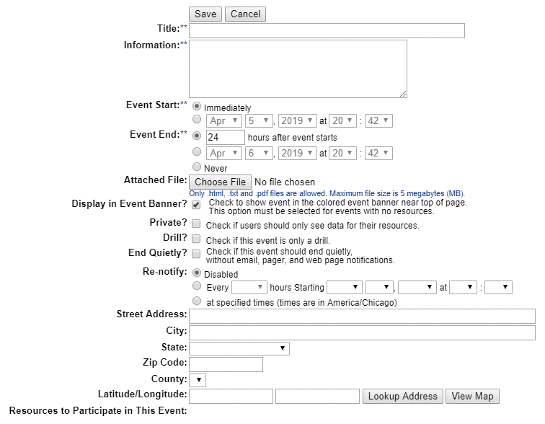
Enter Event Information
Attached file feature can be used to attach document, file, or photo to announcement.
Event end defaults to 24 hours after event starts. If longer than that, change to never.
Information: include specific and relevant information. If communication outage, share alternative means of communication. Include when issue is expected to be resolved if known.
Title: Be clear but brief. Include facility/location affected. Do not use acronyms.
Make sure display in event banner is checked.
CHECK DRILL IF THIS IS NOT A REAL EVENT!!!
End quietly will end event without issuing another email/text/pop up notification.
Re-notify will re-ping selected parties at intervals you select. Do not use unless you are requesting new information at regular intervals (such as supply inventory updates).
You can include a specific address for responding partners or leave blank.
IMPORTANT: Make sure all facilities you want a response from are selected under “resources to participate in this event”
Select all by checking box in black bar next to “Resource Name”
FACILITIES NOT CHECKED WILL NOT BE ABLE TO RESPOND!!!
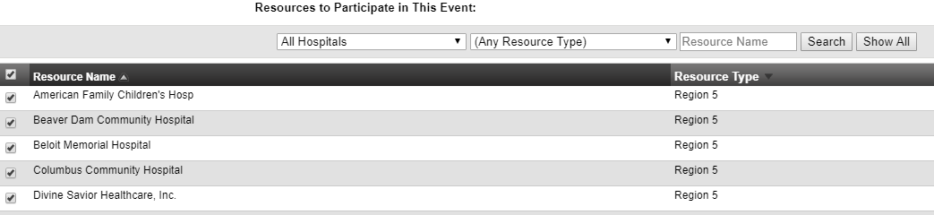
Checking this box will select all
Double check your notification:
- Correct Event
- Correct Facility/Location
- Correct and specific information supplied for partners to act on announcement
To launch the alert, click “Save” at the bottom of the page
To update event:
Scroll over “Event” Click “Event Management”, find your event and click “Edit”

Add updates and click “Save” at bottom of the page. This will issue a new set of text/email/pop up alerts.
To end event:
You should only end events that you created or someone asked you to end. Do not end any other events without consulting with that event’s creator!
Scroll over “Event” Click “Event Management”, find your event and click “End”

