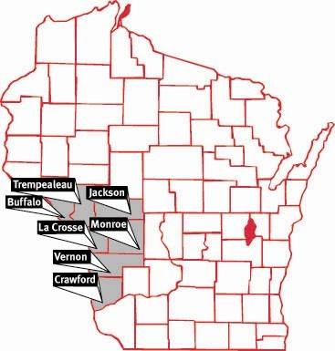  JUNE 3 – 8:00-12:00  Gundersen Rasmus Center  Gundersen Health System –  La Crosse |  | Region 4 Joint Partners MEETING  In person and online
Overview  Understand what we do as a coalition, showcase what we have done, where we are heading  Contact  PHONE:  HERC Coordinator – 608-751-0698  RTAC Coordinator – 608-792-3074  WEBSITE:  https://www.wheppwesternhcc.org/  EMAIL:  Loren.klemp@gmail.com  gbreengmss@gmail.com  Executive Board members  Chair – James Newlun  Vice Chair – Tia Meyer  Medical Advisor – Dr. Chris Eberlein  Treasurer – Tom Tornstrom  Secretary – Vacant  Hospital - Vacant  Greg Breen  Bob Ritger  Tiffany Geisler  Kristina Page  2021/2022 Meeting Dates  August 5, 2021  October 7, 2021 (Tomah Health)  December 2, 2021  February 3, 2022  April 7, 2022  June 2, 2022 (Joint Meeting) |  | aGENDA  Registration 8:00-8:30  Welcoming Remarks – James Newlun  8:30 – 9:00  Administrative Announcements  - Vote on Secretary Nominee(s)  Budget  Goals  Coordinator Updates – Bill Klemp  9:00 - 9:30  - Scope of Coordinator and the future  - Patriot Exercise (SMSgt Davies)  - 2021/2022  SWRTAC Coordinator – Greg Breen  9:30-9:45  - What have we done?  - What’s ahead for EMS in 2021/2022  DHS 118 Updates – Dr. Mason Fisher  9:45- 10:10  Updates on the new 118  What does this mean for your hospital?  BREAK: 10:10 – 10:20  Medical Advisor Perspective – Dr. Chris Eberlein  10:20-10:45  - Updates/New practices as a Medical Advisor since Pandemic  - Current initiatives  Patient Tracking – Jennifer Benke & Rob Goodland  10:45-11:20  - Patient tracking demonstration with EMTrack  eICS – Brian Kaczmarski  11:20-11:45  - eICS demonstration  Wrap Up – James Newlun  11:45-12:00  - New business, final comments, Adjourn  Social Event at “The Recovery Room” 901 7th St S, La Crosse, WI 54601

